The Entity-Relationship (E-R) diagram is used to illustrate the logical structure of the database. It shows the main entities, their attributes, and the relationships between them. This diagram helps in understanding how data is organized and how different tables are connected in the system.
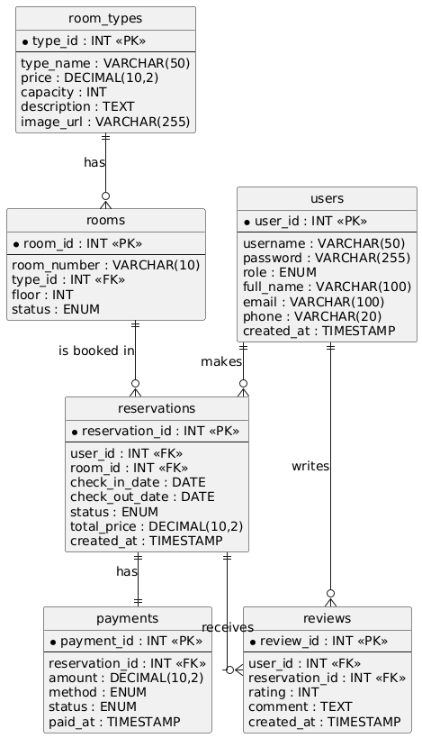
Figure 4 E-R Diagram of the Hotel Reservation Management System
As shown in Figure 4, the database consists of six main entities: users, room_types, rooms, reservations, payments, and reviews. A user (Guest) can make multiple reservations, and each reservation is linked to one room and one user. A room belongs to one room type, and one room type can have multiple rooms. Each reservation has exactly one payment record, and a reservation can receive reviews from users. These relationships ensure that the data is consistent and that the system can efficiently track reservations, payments, and customer feedback.

